

**PROGRAMME :**

**DIPLOMA IN INFORMATION TECHNOLOGY**

**(DIGITAL TECHNOLOGY)(DDT)**

**COURSE:**

**DFP30243- OBJECT ORIENTED PROGRAMMING**

|  |  |  |
| --- | --- | --- |
| **ASSESMENT** | **CASE STUDY 2** | |
| **NO** | **REGISTRATION NO** | **NAME** |
| 1. | 32DDT20F2027 | MUHAMMAD ZAID AIMAN BIN MOHAMMED ZAIDI |
| 2. | 32DDT20F2029 | MUHAMMAD AFIQ MUHAIMIN BIN MOHD ZAINI |
| **PROGRAMME** | DDT | |

INSTRUCTIONS :

1. Answer **ALL** the questions.
2. Submission Date : ……………………………………………………

|  |  |  |  |  |
| --- | --- | --- | --- | --- |
| Description: logo baru PMTG | | | | |
| **CODE / COURSE** | **DFP30243-OBJECT ORIENTED PROGRAMMING** | **CASE STUDY** | **~~1 /~~ 2** | |
| **PROGRAM / CLASS** | **DDT3A** | **DURATION** | **3 HOURS** | |
| **STUDENT’S NAME** | **MUHAMMAD ZAID AIMAN BIN MOHAMMED ZAIDI**  **MUHAMMAD AFIQ MUHAIMIN BIN MOHD ZAINI** | **CLO** | **2P** |  |
|  |  |
| **REG. NO.** | **32DDT20F2027**  **32DDT20F2029** | **TOTAL MARKS** | **/10** | |
| **LECTURER’S NAME** | **PN. HAZLEENA BINTI OSMAN** |

**Topic**: Explain the relationships between Classes

**Learning Outcomes**: At the end of this case study, student able to display skills to use graphical/ visual data to visualize the concept of OOP

**Answer the questions based on the following requirements:**

The system we will be modeling is for Hotel Booking System. As a software designer, you are required to come out with UML class diagram to represent the classes and relationships that the system might have. The following steps are involved in building an object-oriented system:

1. Identify classes for the system
2. Describe the attributes and methods in each class.
3. Establish **relationships** among classes.

**Table 1.0: Basic Requirement List**

| **No.** | **Requirement (attributes** **and methods)** | **Class** |
| --- | --- | --- |
| 1. | User id and password needed.  Able verify during login. | User |
| 2. | Subclass of User class.  Customer name, address, email and credit card info are needed.  Able to register, login and update the profile | Customer |
| 3. | Subclass of User class.  Administrator name and email needed.  Able to update the catalog hotel | Administrator |
| 4. | Part of Customer class (without Customer, no booking will exist).  Booking id, booking date, check in and check out date, customer id, customer name, room type, room cost, room id, cost per night, booking total.  Able to place an order. | Booking |
| 5. | Part of Customer class (without Customer, no booking will exist).  Booking id, room id, room name, check in and check out date.  Able to booking the room, update the check in and check out date, view all booking details and confirm the booking. | Booking Cart |

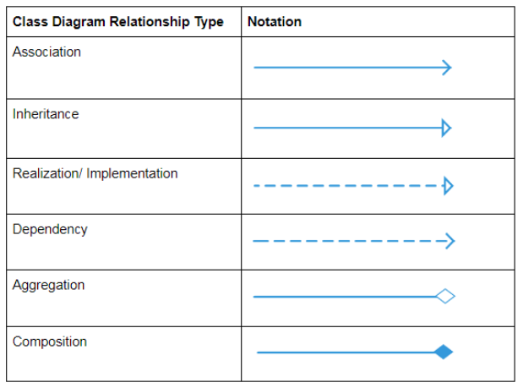

Figure 1: Relationship type

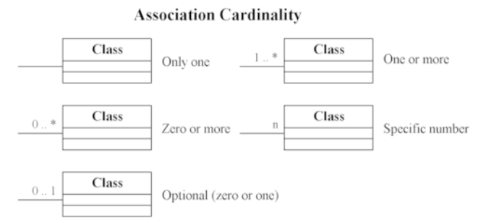

Figure 2: Cardinality

UML enable the classes and their interrelationship to be modelled via class diagram. Read and analyze the entire scenario given in **Table 1.0** to identify attributes and method of each classes. Finally draw all the classes in UML’s class diagram together with the **relationship between classes (refer to figure 1 and 2)**. Make sure the name for all the classes, attributes and methods are according to the naming convention. No arbitrary name are allowed in the class diagram. Your case study report must consist of introduction, body of report where you analyze and visualize the class using class diagram and finally the conclusion of the report.

